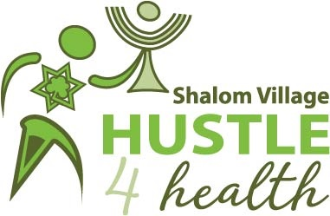
The 19th Annual Shalom Village
Hustle 4 Health
Donation/Pledge Form
Sunday, May 31, 2020

Walker/Runner :____________________________________________________________

Address:__________________________________________________________________

Email: ___________________________________________________________________

Phone:___________________________________________________________________

Collect pledges and help us ensure our residents stay fit and healthy. For every $100 collected, your name will be entered to win great prizes, including a flat screen TV.

Sponsor Name & Email | Address with Postal Code | Donation Amount | Paid  Y/N | Tax Receipt Y/N

