 |  |  |  | 1  10:30 Spa Morning  11:15 Hello Visits  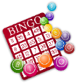  2:15 Bingo (Zucker)  3:30 Wine Time | 2  10:30 Road Runners Walking Club  2:30 Ice Cream Cart
3
10:30 Hello Visits
2:15 Bingo (Goldblatt
4  10:30 Spa Morning  11:15 Hello Visits  2:30 Games Afternoon in the Garden (SVO Garden)  4:15 Montessori  6:30 Treats on the Balcony | 5  10:30 Stretch & Strengthen  (Zucker)  2:30 Rosh Hashanah Card Making (Goldblatt  6:30 Move & Groove | 6  10:30 Book Club with Kyle (Goldblatt)  12:00 Valentino Take Out Lunch (Family Dining Room)  2:15 Café Time (Bubbi Bessie’s Café)  3:00 Scrabble (Gould)  6:30 Trivia Night (Goldblatt) | 7  10:30 Hamilton Public Library Outing  10:30 Ask the Rabbi  2:15 Bingo (Zucker)  3:30 Hello Visits  6:30 Outdoor Time | 8  10:30 Stretch & Strengthen (  11:15 Hello Visits  2:15 Bingo (Zucker)  3:30 Wine Time | 9  10:30 Hello Visits  2:15 Road Runners Walking Club
10
10:30 Hello Visits
2:15 Bingo (Goldblatt)
11  10:30 Road Runners Walking Club  2:30 Resident’s Council Celebration (Bubbi Bessie’s Café)  3:30 Hello Visits  4:15 Montessori  6:30 Musical Memories | 12  10:30 Barley the Dog Visits with Karine  11:15 Hello Visits  2:30 Movie Afternoon (Classic Theater)  6:30 Move & Groove | 13  10:30 Burlington Waterfront Outing  2:30 Sing with Paula (Bubbi Bessie’s Café)  3:00 Scrabble (Gould  6:30 Card Games (Goldblatt) |   14  10:30 Hello Visits  10:30 Ask the Rabbi  12:00 Happy Birthday Pietra Goldblatt)  2:30 Pietra ‘s 101 Birthday Celebration (Goldies)  6:30 Outdoor Time | 15  10:30 Bingo (Zucker)  11:15 Hello Visits  2:30 Decorating for Rosh Hashanah  5:00/5:30 Rosh Hashanah Dinner (All Dining Rooms) | 16 Rosh Hashanah  9:30 Ohev Zedek Service (Synagogue)  10:30 Hello Visits  2:15 Coffee Cart
17 Rosh Hashanah
9:30 Ohev Zedek Service (Synagogue)
10:30 Hello Visits
3:45 Rosh Hashanah Service (Synagogue)-Blowing the Shofar
18  10:30 Burlington Mall  2:00 Café Time (Bubbi Bessie’s)  3:30 Hello Visits  4:15 Montessori  6:30 Musical Memories | 19  10:30 Stretch & Strengthen (Goldblatt)  11:15 Hello Visits  2:30 Treat Cart  6:30 Move & Groove | 20  10:30 Book Club with Kyle  Noon Happy Birthday Barbara  2:15 Spa Afternoon  3:00 Scrabble (Gould)  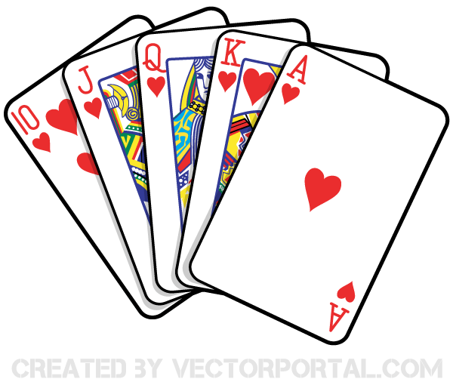  6:30 Card Games (Goldblatt) | 21  10:30 Stretch & Strengthen  10:30 Ask the Rabbi  11:15 Hello Visits  2:15 Bingo (Zucker)  3:30 Hello Visits  6:30 Outdoor Time | 22  10:30 Spa Moring  2:30 Bingo (Zucker)  3:30 Wine Time | 23  10:30 Road Runners Walking Club  12:30 Happy Birthday Mrs. Kim (Gould)  2:15 Montessori
24 EREV YOM KIPPUR
10:30 Montessori
2 PM Non –denominational Service
(Goldies)
7PM Kol Nidre Service (Synagogue)
25 Yom Kippur  9:30 Ohev Zedek Service (Synagogue)  11:15 Hello Visits  3:45 Yom Kippur Service (Synagogue)  6:30 Tea & Chat | 26  10:30 Barely the dog with Karine  11:15 Hello Visits  2:30 Cross Word (Zucker)  6:30 Move & Groove with Kyle | 27  10:30 Book Club with Kyle  2:30 Sukkah Wall Hanging (Goldblatt)  6:30 Card Games (Goldblatt) | 28  10:30 Farmer’s Market Outing  2:15 Bingo (Zucker)  3:30 Residents Council (Ravencliffe)  6:30 Outdoor Time | 29 Erev Sukkot  10:30 Decorating the Sukkah  2:30 Bingo (Zucker)  3:30 Wine Time | 30 Sukkot  10:30 Visiting the Sukkah  2:15 Tea & Chat ( Zucker)  3:30 Hello Visits

