1  10:30 Stretch & Strengthen (GB)  2:15 Café Time (Bubbi Bessie’s Café)  3:15 Story Reading (GB)  4:30 Montessori  6:30 Bowling Night | 2  10:30 Barley the Dog Visits  11:15 Relaxing Music (GB)  2:30 Knit & Chat (Sunroom)  4:30 Montessori  6:30 Move & Groove | 3  10:30 Book Club with Kyle (GB)  11:15 Zen Time (GB)  2:15 Music with Zev (Bubbi Bessie’s Café)  3:00 Scrabble (GD)  4:00 Montessori  6:30 Card Games (GB) | 4  10:30 Sing with Paula (Bubbi Bessie’s Café)  10:30 Ask the Rabbi  11:15 Montessori (GB)  2:15 Bingo (GB)  6:30 Musical Memories | 5  10:30 SPA Morning  11:15 Story Reading (Sunroom)  12:30 Happy Birthday Henrietta (GD) 101  2:30 Bingo (GB)  3:30 Wine Time | 6  10:30 Hello Visits  2:15 Montessori
7
10:30 Stretch & Strengthen ( GB)
12:30 Happy Birthday Jung (GD)
2:15 Bingo (GB)
8  10:30 Stretch & Strengthen(GB)  2-4:30 Relaxation /Social Time Goldblatt Dining Room  6:30 Trivia  Solar Eclipse | 9  10:30 Milli Cruise  2:30 Movie (Classic Theatre.)  4:15 Montessori  6:00 Soup Making (Goldies) | 10  10:30 Book Club with Kyle (GB)  11:15 Relaxing Music (GB)  2:30 Black Forrest Inn Outing  3:00 Scrabble (GD)  6:30 Puzzle Night (Sunroom) | 11  10:30 Kehila Kids Program (Samuels)  10:30 Ask the Rabbi  2:15 Bingo (GB)  3:30 Story Reading  6:30 Hot Chocolate Cart | 12  10:30 Making Pillowcases/ Decorating Matzah Covers (Art Room)  11:30 Story Reading  2:15 Bingo (GB)  3:15 Wine Time | 13  10:30 Hello Visits  2:15 Coffee Cart
14
10:30 Montessori
2:30 Bingo (GB)
15  10:30 Stretch & Strengthen (GB)  11:15 Story Reading (GB)  2:15 Café Time (Bubbi Bessie’s)  3:30 Hello Visits  4:15 Montessori  6:30 Pub Night with Matilda (Goldies) | 16  10:30 Barley the Dog Visits  11:15 Relaxing Music (GB)  12:00 Pizza Take (FDR)  2:30 Knit & Chat (1st Floor Sunroom)  3:30 Hello Visits  4:15 Montessori  6:30 Men’s Club Pool Night (SV2 Apt) | 17  10:30 Book Club with Kyle (GB)  11:15 Relaxing Music (GB)  2:30 Blueberry Crumble Cart  3:00 Scrabble (GD)  4:00 Montessori  6:30 Trivia Night (GB) | 18  10:30 Market Outing  10:30 Ask the Rabbi  12:30 Happy Birthday Marcela (GD)  2:15 Bingo (GB)  3:30 Montessori  6:30 Musical Memories | 19  10:30 Making Challah Bread (Family Dining room)  11:30 Montessori (Sunroom)  2:15 Bingo (GB)  3:30 Wine Time | 20  10:30 Hello Visits  2:15 Montessori
21
10:30 Stretch & Strengthen (GB)
2:00 Non-Denominational Services (Goldies)
3:30 Leon Birthday 2nd floor Lounge Area
22 EREV OF PASSOVER  10:00 Story Reading (GB)  11:15 Making Seder Plates ( Art Room)  12:30 Happy Birthday Leon (GD)  2:30 Hot Chocolate Cart  5:15 Seder Dinner( Goldies) | 23 PASSOVER  10:30 Stretch & Strengthen (GB)  11:15 Story Reading (GB)  2:30 Coffee Time (GB)  4:15 Montessori  6:30 Current Events Chat (GB) | 24 PASSOVER  10:30 Residents Council (OK)  11:15 Zen Time (GB)  2:30 Stretch & Strengthen (GB)  4:00 Montessori  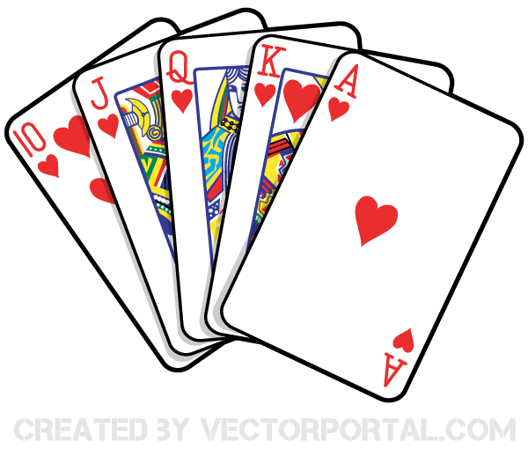  6:30 Tea & Chat (GB) | 25 PASSOVER  10:30 Stretch & Strengthen (GB)  11:15 Montessori (Sunroom)  10:30 Ask the Rabbi  2:15 Bingo (GB)  3:30 Hello Visits  6:30 Hot Chocolate Cart | 26 PASSOVER  10:30 SV0 Starbucks Outing  2:15 Bingo (GB)  3:15 Wine Time  3:30 Relaxing Music (Sunroom) | 27 PASSOVER  10:30 Montessori (GB)  3:15 Hello Visits
28 PASSOVER
10:30 Stretch & Strengthen (Goldblatt)
2:15 Bingo (GB)
29 PASSOVER  10:30 Hello Visits  2:15 Café Time (Bubbi Bessie’s)  3:30 Story Reading (Sunroom)  4:15 Montessori  6:30 Trivia Night (Sunroom) | 30 PASSOVER  10:30 Barley the Dog Visits  11:30 Montessori  2:15 Tea & Chat (GB)  3:45 Yizkor Service (Synagogue)  6:30 Current Events

