1  10:30 Walking Club  2:15 Café Time (Bubbi Bessie’s Café)  3:15 Story Reading (Sunroom)  6:30 Bowling Night | 2  10:30 Barley the Dog Visits  11:15 Relaxing Music (Sunroom)  2:30 Knit and Chat (Sunroom)  6:30 Move & Groove | 3  10:30 Book Club with Kyle (GB)  11:15 Zen Time (Sunroom)  2:15 Music with Zev (Bubbi Bessie’s Café)  6:30 Card Games (GB) | 4  10:30 Sing with Cantor Paula (Bubbi Bessie’s Café)  10:30 Ask the Rabbi  11:15 Montessori (Sunroom)  2:15 Bingo (WZ)  3:30 Montessori  6:30 Musical Memories | 5  10:30 SPA Morning  11:15 Story Reading (Sunroom)  12:00 Happy Birthday Janice  2:30 Bingo (WZ)  3:30 Wine Time | 6  11:30 Hello Visits  3:15 Montessori (Sunroom)
7
11:30 Stretch & Strengthen (ZK)
2:15 Bingo (GB)
8  10:30 Stretch & Strengthen (Zucker)  2:00 -4:30 Relaxation /Social Time (Zucker House)  6:30 Trivia Night (GB)  Solar Eclipse | 9  10:30 Milli Cruise  2:30 Movie Afternoon (Classic Theatre)  3:30 Montessori  6:00 Soup Making (Goldies) | 10  10:30 Book Club with Kyle (GB)  11:15 Relaxing Music (WZ)  2:30 Black Forrest Inn Outing  6:30 Puzzle Night (Sunroom) | 11  10:30 Kehila Kids Program (Samuels)  10:30 Ask the Rabbi  2:15 Bingo (WZ)  3:30 Montessori  6:30 Hot Chocolate Cart | 12  10:30 Making Pillowcases/ Decorating Matzah Covers (FDR)  11:30 Story Reading  2:15 Bingo (WZ)  3:15 Wine Time | 13  11:30 Hello Visits  2:15 Coffee Cart
14
11:30 Hello Visits
2:30 Bingo (GB)
15  10:30 Stretch & Strengthen (ZK)  11:15 Story Reading (Sunroom)  2:15 Café Time (Bubbi Bessie’s)  3:30 Hello Visits  6:30 Pub Night with Matilda (Goldies) | 16  10:30 Stretch & Strengthen (ZK)  10:30 Barley the Dog Visits 11:15 Relaxing Music (Sunroom)  Noon Pizza Take Out (FDR)  2:30 Coffee Hour (WZ)  3:30 Hello Visits  6:30 Men’s Club Pool Night (SV2 Apt) | 17  10:30 Book Club with Kyle (GB)  11:15 Relaxing Music (Sunroom)  2:30 Blueberry Crumble Cart  6:30 Trivia Night (GB) | 18  10:30 Market Outing  10:30 Ask the Rabbi  2:15 Bingo (WZ)  3:30 Montessori  6:30 Musical Memories | 19  10:30 Making Challah Bread (Family Dining room)  11:30 Montessori (Sunroom)  2:15 Bingo (WZ)  3:30 Wine Time | 20  11:30 Hello Visits  3:15 Montessori (Sunroom)
21
11:30 Stretch & Strengthen (ZK)
2:00 Non-Denominational Services (Goldies)
22 EREV OF PASSOVER  10:00 Story Reading (GB)  11:15 Making Seder Plates  2:15 Hot Chocolate Cart  5:15 Seder Dinner (Goldies) | 23 PASSOVER  10:30 Stretch & Strengthen (ZK)  11:15 Story Reading (Sunroom)  2:30 Tea & Chat (ZK)  6:30 Current Events (GB) | 24 PASSOVER  10:30 Residents Council (OK )  11:15 Zen Time (Sunroom)  2:30 Coffee Cart  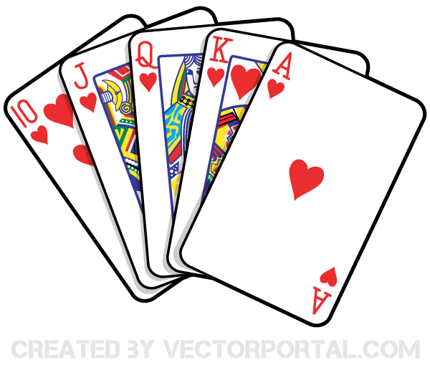  6:30 Tea & Chat (GB) | 25 PASSOVER  10:30 Stretch & Strengthen (ZK)  11:15 Montessori (Sunroom)  10:30 Ask the Rabbi  2:15 Bingo (WZ)  3:30 Montessori  6:30 Hot Chocolate Cart | 26 PASSOVER  10:30 Starbucks Outing  12:00 Happy Birthday Richard  2:15 Bingo (WZ)  3:30 Wine Time | 27 PASSOVER  11:30 Montessori (Sunroom)  3:15 Hello Visits
28 PASSSOVER
11:30 Stretch & Strengthen (ZK)
2:15 Bingo (Goldbaltt)
29 PASSOVER  10:30 Hello Visits  2:15 Café Time (Bubbi Bessie’s)  3:30 Story Reading (Sunroom)  6:30 Trivia Night (Sunroom) | 30 PASSOVER -  10:30 Stretch & Strengthen (ZK)  10:30 Barley the Dog Visits  11:15 Relaxing Music  2:15 Tea & Chat (ZK )  3:45 Yizkor Service (Synagogue)  6:30 Current Events (GB)
Legend:
SVO SV2
GB-Goldblatt OK-Oak Knoll
GD-Gould EF-Effort Square
ZK-Zucker MF-Mayfair
WZ-Weisz RC-Ravenscliffe FDR ( Family Dining Room)

