 |  |  | 1 Israeli Independence Day  10:30 Israeli Independence Day Services (TBA) )  2:30 Israeli Independence Day Program (Bistro)  3:30 Hello Visits  6:30 Treat Cart | 2  10:30 Snoezelen (OK)  11:15 Relaxing Music  12:30 Happy Birthday Joan (GD)  2:15 Bingo (GB)  3:15 Wine Time | 3  11:15 Walking Club  3:15 Montessori
4
11:15 Hello Visits
2:00 Non-Denominational Services (Goldie’s)
5  10:30 Burlington Mall Outing  2:30 Café Time (Bubbi Bessie’s Café)  3:30 Hello Visits  4:15 Montessori  6:30 Walking Club | 6  10:30 Stretch & Strengthen (GB)  11:15 Story Reading  2:30 Movie Afternoon (Classic Theatre)  4:15 Montessori  6:30 Dance Club with Kyle (2nd Floor Main Area) | 7  10:30 Mother’s Day Card Making (Art Room)  11:15 Hello Visits  12:00 Happy Birthday Joe B (GB)  2:30 Joe’s 100th Birthday Celebration featuring Aiden Purnell (Bubbi Bessie’s Café)  4:00 Montessori  6:30 Puzzle Night (2nd Floor Sunroom) | 8  10:30 Obie Games (OK)  11:15 Relaxing Music  11:15 Ask the Rabbi  2:15 Bingo (GB)  3:15 Hello Visits  6:30 Outdoor Time | 9  10:30 :Bingo (GB)  11:15 Relaxing Music  2:30 Challah Making (OK)  3:30 Wine Time | 10  11:15 Walking Club  2:30 Hello Visits
11 Mother’s Day
11;30 Hello Visits
12:00 Happy Birthday Keith (GB)
2:15 Mother’s Day Celebration featuring the Hamilton Philharmonic Orchestra (Goldie’s)
12  10:30 Snoezelen (OK)  11:15 Walking Club  2:30 Café Time (Bubbi Bessie Café)  3:30 Hello Visits  4:15 Montessori  6:30 Bowling (2nd Floor Main Area) | 13  10:30 Planting  Vegetables (SV0 Garden)  2:30 Knit & Chat (1st Floor Sunroom)  4:15 Montessori  6:30 Dance Club with Kyle (2nd Floor Main Area) | 14  10:30 Grand Dad’s Doughnuts & Cruise Outing  2:00 Ice Cream Truck  3:00 Scrabble (GD)  4:00 Montessori  6:30 Walking Club | 15  10:30 Obie Games ((OK))  11:15 Story Reading  11:15 Ask the Rabbi  2:15 Bingo (GB)  3:15 Hello Visits  6:30 Outdoor Time | 16 Lag B’Omer  10:30 Bingo (GB)  11:15 Relaxing Music  1 PM Come Listen to Music - SVO Balconies / FDR  2:45 Lag B’Omer Ice Cream Sundaes (Zucker)  3:30 Wine Time | 17  11:30 Walking Club  3:15 Montessori
18
10:30 Stretch & Strengthen ( Goldblatt)
2:15 Bingo (GB)
19 Victoria Day  10:30 Snoezelen (OK)  11:15 Relaxing Music  2:30 Outdoor Time (SVO Garden)  4:15 Montessori  6:30 Treat Cart | 20  10:30 Travel Talk South Africa (Ok)  2:30 Spa Afternoon  4:15 Montessori  6:30 Dance Club with Kyle (2nd Floor Main Area) | 21  10:30 Bible Study (Bistro)  11:30 Walking Club  2:30 Sing with Paula (Bubbi Bessie’s Café)  3:00 Scrabble (GD)  4:00 Montessori  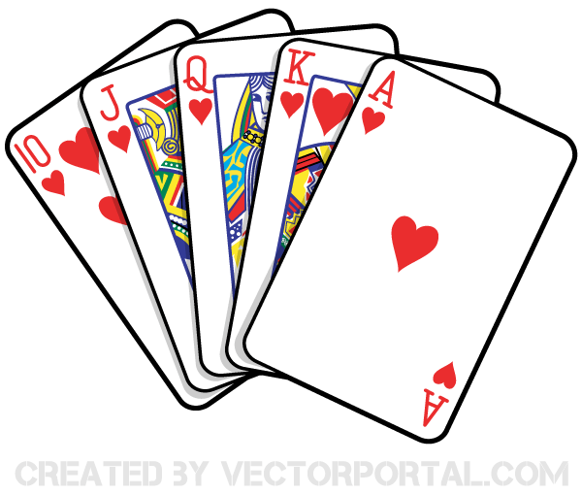  6:30 Name that Tune (2nd Floor Main Area) | 22  10:30 Obi (OK)  11:15 Story Reading  11:15 Ask the Rabbi  2:15 Bingo (GB)  3:15 Hello Visits  6:30 Outdoor Time | 23  10:30 Hymn Sing (Bistr0)  2:15 Hello Visits  3:00 Preshabbat with Rabbi Beni (Synagogue) | 24  10:30 Shabbat Services (Synagogue) followed by Kiddush Lunch (Goldie’s)  3:15 Montessori
25
10:30 Walking Club
2:15 Bingo (GB)
26 Jerusalem Day  10:30 Jerusalem Day Service (Synagogue)  11:30 Walking Club  2:15 Café Time (Bubby Bessie’s)  3:30 Hello Visits  4:15 Montessori  6:30 Bowling (2nd Floor Main Area) | 27  10:30 Gage Park Outing  2:30 Musical Memories (2nd Floor Main Area)  4:15 Montessori  5:30 Soup Making (Goldies) | 28  10:30 Resident’s Council (OK)  10:45 Snoezelen (OK)  11:15 Food Committee (OK)  2:30 Sing with Judy (Bubbi Bessie’s Cade)  3:00 Scrabble (GD)  4:00 Montessori  6:30 Walking Club | 29  10:30 (Obi) (OK)  11:15 Ask the Rabbi  12:00 Chinese Food Take Out Lunch (2nd Floor Sunroom)  2:15 Bingo (GB)  2:30 Book Club –SV0 Lounge)  3:15 Hello Visits  6:30 Outdoor Club | 30  10:30 Bingo (GB)  11:15 Relaxing Music  2:15 Hello Visits  3:00 Preshabbat with Cantor Paula (Synagogue) | 31  11:30 Montessori  3:15 Walking Club
Legend:
SVO
GD-Gould
GB –Goldblatt
ZK-Zucker
WZ-Weisz
SV2
Oak Knoll

