Legend:  SVO SV2  GD-Gould OK- Oak Knoll  GB –Goldblatt  ZK-Zuck  WZ-Weisz |  |  |  | 1  10:30 Outdoor Time  11:00 Bingo (ZK)  2:15 Bingo (WZ)  3:30 Wine Time | 2  10:30 Outdoor time (ZK)  11:30 Outdoor Time (WZ)
3
10:30 Stretch & Strengthen (ZK)
11:15 Readings Tish B ’av
4  10:30 Stretch and Strengthen (ZK)  11:30 Hello Visits  2:30 Ice cream Cart  6:30 Treat Cart | 5  10:30 Hello Visits  11:30 Relaxing Music  2:15 Crossword (ZK)  6:30 Popsicle Cart | 6  10:30 Outdoor Time  11:30 Hello Visits  2:30 Games Afternoon (ZK)  3:30 Hello Visits | 7  10:30 Obie Games (OK)  11:15 Hello Visits  11:30 Ask the Rabbi  2:15 Bingo (WZ)  3:15 Montessori  6:30 Outdoor Time | 8  10:30 Farmers Market  2:15 Bingo (WZ)  3:30 Wine Time | 9  10:30 Outdoor Time  2:30 Hello Visits
10
10:30 Jewish sing along (2nd Floor)
2:00 Interdenominational Service (Goldies)
11  10:30 Snoezelen (OK)  11:15 Relaxing Music  2:30 Cafe Time (Bubbi Bessie’s Cafe)  6:30 Bowling (Font Area 2nd Floor) | 12  10:30 Obie Games (OK)  11:30 Walking Club  2:30 Oscar the Dog Visit  6:30 Men's club with Kyle and Amanda (4th floor) | 13  10:30 Movie Morning (Classic Theatre)  2:30 Outdoor Time  3:15 Hello Visits  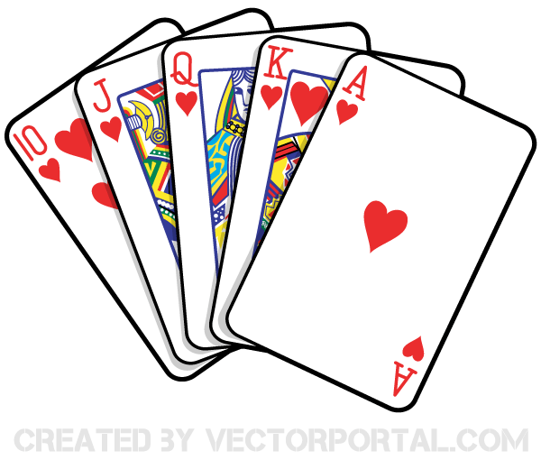  6:30 Walking Club (Outside) | 14  10:30 Hello Visits  11:15 Ask the Rabbi  11:30 Garden Lunch Gould & Goldblatt (SVO Garden)  2:15 Bingo (WZ)  3:15 Montessori  6:30 Outdoor Time | 15  10:30 Bingo (ZK)  11:30 Walking Club  2:15 Challah Making (OK)  3:30 Wine Time | 16  10:30 Stretch & Strengthen (Zucker)  2:15 Montessori
17
10:30 Walking Club
3:15 Bingo (WZ)
18  10:30 Obie Games (OK)  11:30 Hello Visits  2:15 Concert with Paula French (SVO Garden)  3:30 Hello Visits  6:30 Cupcake Making (Goldies) | 19  10:30 Travel Talk England (Ok)  11:15 Relaxing Music  2:30 CCP Outing  5:30 Soup Program (Goldies) | 20  10:30 Snoezeleon  11:30 Short Stories with Kyle  2:30 Spa Afternoon  6:30 Walking Club (Outside) | 21  10:30 Williams Pub Outing  11:15 Ask the Rabbi  2:15 Bingo (ZK)  3:15 Montessori  6:30 Outdoor Time | 22  10:30 Bible Study (Bistro)  11:15 Relaxing Music  2:15 Bingo (WZ)  3:30 Wine Time | 23  10:30 Shabbat Services (Synagogue) followed by Kiddush Lunch (Goldies)  2:15 Walking Club
2410:30 Making Perogies with Andrea (Goldies)
Noon Happy Birthday Jeremy
3:15 Bingo (WZ)
25  10:30 Obie Games  11:30 Walking Club  2:15 Café Time (Bubby Bessie’s)  3:30 Hello Visits  6:30 Popsicle Cart | 26  10:30 Burlington Mall Outing 2:30 Bocce Ball (SVO Garden)  4:15 Montessori  6:30 Dance Club with Kyle (Front Area 2nd Floor) | 27  10:30 Hymn Sing (Bistro)  11:30 Hello Visits  2:30 Outdoor Time Garden  6:30 Walking Club (Outside) | 28  10:30 Hello Visits  11:15 Ask the Rabbi  10:30 Garden Lunch Zucker & Weisz (SVO Garden)  2:15 Bingo (WZ)  3:15 Montessori  6:30 Outdoor Time | 29  10:30 Resident’s Council (OK)  10:45 Snoezelen (OK)  11:00 Food Committee (OK)  2:30 Sing with Paula SV0 Garden  3:15 Wine Time | 30  10:30 Montessori  2:30 Walking Club
31
10:30 Stretch & Strengthen (Goldblatt)
3:15 Bingo (WZ)

