Legend:  SVO SV2  GD-Gould OK- Oak Knoll  GB –Goldblatt  ZK-Zuck  WZ-Weisz | 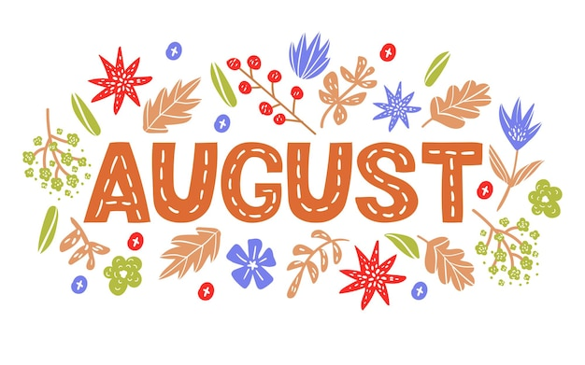 |  |  | 1  10:30 Musical Memories (GD)  11:15 Hello Visits  2:30 Scrabble (Sunroom)  3:15 Musical Memories (GB) | 2 Tisha B'av  12:00 Happy Birthday Marie (GB)  2:30 Fruit Punch (Cart)
3 Tisha B'av
2:15 Short Stories (GD)
3:15 Short Stories (GB)

4  10:30 Outdoor Time  11:15 Hello Visits  2:30 Ice Cream Cart  3:30 Montessori (GB)  6:30 Treat Cart | 5  10:30 Tea & Coffee Cart  11:15 Relaxing Music  2:30 Musical Memories  3:15 Hello Visits  6:30 Popsicle Cart | 6  10:30 Stret  2:30 Art Afternoon (GD)  3:00 Scrabble (GD)  4:00 Montessori  6:30 Trivia | 7  10:30 Obie Games (OK)  11:15 Relaxing Music  11:15 Ask the Rabbi  2:15 Bingo (GB)  3:15 Hello Visits  6:30 Outdoor Time | 8  10:30 Farmer’s Market  2:15 Bingo (GB)  3:30 Wine Time | 9  11:15 Outdoor Time  3:15 Hello Visits
10
10:30 Jewish Sing Along (GB)
2:00 Non-Denominational Services (Goldies)
11  10:30 Snoezelen (OK)  11:15 Stretch & Strengthen)  2:30 Café Time (Bubbi Bessie Café)  3:30 Hello Visits  4:15 Montessori  6:30 Bowling (Font Area 2nd Floor) | 12  10:30 Obie (OK)  11:15 Relaxing Music  2:30 Oscar the Dog Visits  3:15 Hello Visits  4:15 Montessori  6:30 Men’s Club with Amanda and Kyle | 13  10:30 Movie Morning (Classic Theatre)  2:30 Outdoor Time (SVO Garden)  3:00 Scrabble (GD)  4:00 Montessori  6:45 Walking Club | 14  10:30 Hello Visits  11:15 Ask the Rabbi  11:30 Garden Lunch for Gould & Goldblatt (SVO Garden)  2:15 Bingo (GB)  3:15 Hello Visits  6:30 Outdoor Time | 15  10:30 Bingo (GB)  11:30 Walking Club  12:00 Happy Birthday Sheila (GB)  2:30 Challah Making (OK) | 16  10:30 Stretch & Strengthen (GB)  3:15 Montessori
17
10:30 Outdoor Time
2:15 Bingo (GB)
18  10:30 Obie Games (OK)  11:15 Walking Club  12:30 Happy Birthday Robert (GD)  2:30 Paula French Concert (SVO Garden)  4:15 Montessori  6:30 Cupcake Making (Goldies) | 19  10:30 Travel Talk England (OK)  11:15 Relaxing Music  2:30 Popsicle Cart  4:15 Montessori  5:30 Soup Program (Goldies) | 20  10:30 Snoezelen (OK)  11:30 Short Stories with Kyle  2:30 Spa Afternoon  3:00 Scrabble (GD)  4:00 Montessori  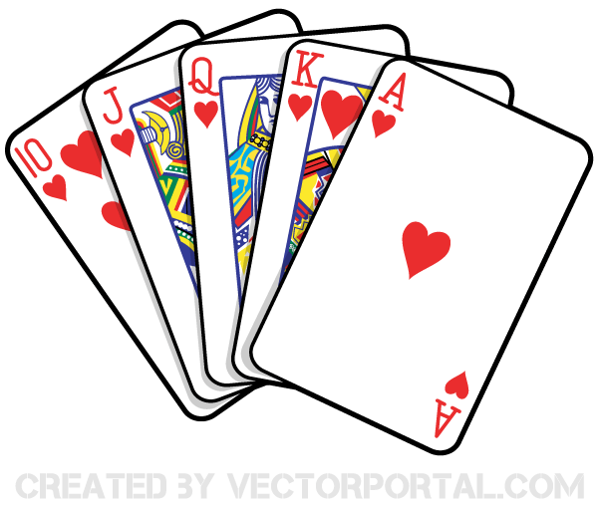  6:45 Walking Club | 21  10:30 Williams Pub Outing  11:15 Ask the Rabbi  12:30 Happy Birthday Joyce P (GD)  2:15 Bingo (GB)  3:15 Hello Visits  6:30 Outdoor Time | 22  10:30 Bible Study (Bistro)  11:30 Relaxing Music  2:15 Bingo (GB)  3:15 Wine Time | 23  10:30 Shabbat Services (Synagogue) followed by Kiddush Lunch (Goldies)  3:15 Walking Club
24
10:30 Making Perogies with Andrea (Goldies)
2:15 Bingo (GB)
25  10:30 Obie Games  11:15 Story Reading  2:15 Café Time (Bubbi Bessie’s)  3:30 Hello Visits  4:15 Montessori  6:30 Outdoor Time | 26  10:30 Burlington Mall Outing  2:30 Bocce Ball (SVO Garden)  4:15 Montessori  6:30 Dance Club with Kyle (Front Area 2nd Floor) | 27  10:30 Hymn Sing (Bistro)  11:30 Hello Visits  2:30 Outdoor Time SVO Garden  3:00 Scrabble (GD)  4:00 Montessori  6:45 Walking Club | 28  10:30 Hello Visits  11:15 Ask the Rabbi  11:30 Garden Lunch Zucker & Weisz (SVO Garden)  2:15 Bingo (GB)  6:30 Outdoor Time | 29  10:30 Resident’s Council (OK)  10:45 Snoezelen (OK)  11:00 Food Committee (OK)  2:30 Sing with Paula SVO Garden  3:15 Wine Time | 30  11:30 Montessori  3:30 Walking Club
31
10:30 Stretch & Strengthen (GB)
2:15 Bingo (GB)

