Legend:  SVO SV2  GD-Gould OK- Oak Knoll  GB-Goldblatt ES-Effort Square  ZK-Zucker  WZ-Weisz |  | 1 Canada Day  10:30 Book Club with Kyle (GB)  11:30 Walking Club  2:30 Canada Day Celebration featuring Sam &Robin (SVO Garden)  3:30 Montessori  6:30 Power of Positive Speech (Synagogue) | 2  10:30 Travel Talk: Nunavut (Theatre)  11:30 Hello Visits  2:15 Bingo (GB)  3:15 Hello Visits  6:30 Movie Evening ((1st Floor) | 3  10:30 Snoezelen (OK)  11:15 Relaxing Music  12:00 Happy Birthday Margaret (GB)  2:15 Bingo (GB)  3:15 Hello Visits | 4  10:30 Trivia (2nd Floor Main Area)  3:15 Ice Cream Cart
5
10:30 Stretch & Strengthen (GB)
2:15 Bingo (Goldblatt)
6  10:30 Bible Study (Theatre)  11:30 Hello Visits  2:15 Cafe Time (Bubi’s)  4:15 Montessori  6:30 Bowling (2nd Floor Main Area) | 7  10:30 Walking Club  11:30 Gould Garden Lunch (SVO Garden)  2:30 Ice Cream Cart  3:15 Hello Visits  4 PM Montessori  6:30 Men’s Club (Art Room) | 8  10:30 Hymn Sing (Theatre)  11:30 Hello Visits  2:30 Spa Afternoon  3:00 Scrabble (Goldblatt)  4:00 Montessori  6:30 Trivia | 9  10:30 Burlington Mall Outing  11:15 Ask the Rabbi  2:15 Bingo (GB)  3:15 Hello Visits  6:30 Movie Evening (1st Floor) | 10  10:30 Snoezelen (OK)  11:15 Relaxing Music  2:15 Bingo (GB)  3:15 Wine Time | 11  10:30 Stretch & Strengthen (GB)  3:15 Montessori
12
11:15 Coffee Cart
2:00 Nondenominational Services (Goldies)
13  10:30 Stretch & Strengthen (GB)  11:15 Relaxing Music  2:30 Adis Rodriguez & Amed Mitchel (Vocals & Percussion DJ (SVO Garden)  4:15 Montessori  6:30 Sip and Paint with Kyle (Art Room) | 14 Start of 9 Days  10:30 Walking Club  11:30 Hello Visits  2:30 An caster League Snack Bar Outing  4 PM Montessori  6:30 Outdoor Time on the Balcony | 15  10:30 Movie Morning (Theatre)  2:30 Bocce Ball (SVO Garden)  3:00 Scrabble (GD)  4:00 Montessori  6:30 Power of Positive Program (Synagogue) | 16  10:30 Chair Yoga (GB)  11:15 Ask the Rabbi  11:15 Hello Visits  2:15 Bingo (GB)  3:15 Montessori  6:30 Movie Morning (1st Floor) | 17  10:30 Stretch & Strengthen (GB)  11:15 Hello Visits  2:15 Bingo (GB)  3:15 Wine Time | 18  10:30 Shabbat Services (Synagogue) followed by Kiddush Lunch (Goldies)  3:15 Hello Visits
19
10:30 Hello Visits
2:15 Bingo (GB)
20  10:30 Stretch & Strengthen (GB)  11:15 Relaxing Music  2:30 Cafe Time (Bubi’s)  4:15 Montessori  6:30 Outdoor Time (Front Area) | 21  10:30 Summer Cruise  2:30 Oscar the Dog Visits  3:15 Hello Visits  4 PM Montessori  6:30 Men’s Club (Art Room) | 22  10:30 Book Club with Kyle (GB)  11:15 Hello Visits  2:30 Trivia Afternoon  4:00 Montessori  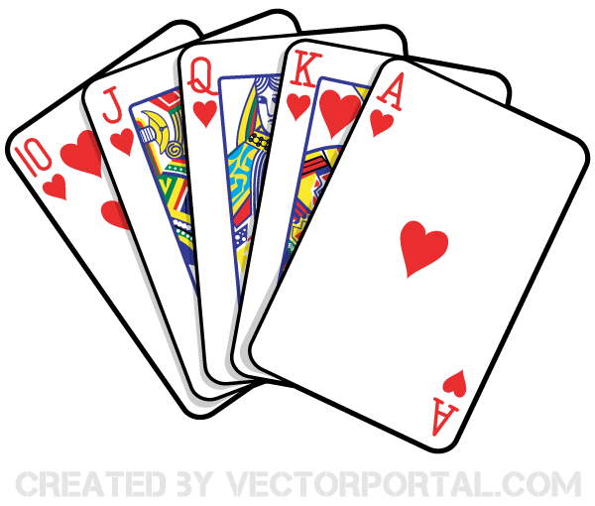  6:30 Games (Main Area) | 23 Tish B’av  10:30 Tish B’av Service (Synagogue)  11:15 Ask the Rabbi  2:15 Bingo (GB)  3:15 Montessori  6:30 Movie Morning (1st Floor) | 24  10:30 Walking Club  11:15 Relaxing Music  2:15 Bingo (GB)  3:15 Wine Time | 25  10:30 Walking Club  3:15 Popsicle Cart
26
10:30 Hello Visits
12:30 Happy Birthday Rosalie (GD)
2:15 Bingo (GB)
27  10:30 OBI (Oak Knoll)30  2:15 Cafe Time (Bubi’s)  3:30 Hello Visits  4:15 Montessori  6:30 Musical Memories | 28  10:30 Walking Club  11:30 Zucker Garden Lunch (SVO Garden)  2:30 Games Afternoon (GB)  3:30 Hello Visits  4 PM Montessori  5:30 Soup Program (Goldies) | 29  10:30 SVO Breakfast Club  11:15 Zen Time  2:30 Sing with Judy (Cafe)  4:00 Montessori  6:30 Power of Positive Program (Synagogue) | 30  10:30 Resident’s Council (OK)  10:45 Snoezelen (OK)  11:00 Food Committee  11:15 Ask the Rabbi  2:15 Bingo (GB)  3:15 Montessori  6:30 Movie Morning (1st Floor) | 31  10:30 Lakeshore Cruise Burlington  12:00 Happy Birthday Joe (GB)  2:15 Hello Visits  3:00 Preshabbat with Cantor Paula (Synagogue) | 

