Legend:  SVO SV2  GD-Gould OK- Oak Knoll  GB-Goldblatt ES-Effort Square  ZK-Zucker  WZ-Weisz | 1  10:30 Obie Games (GD)  11:15 Relaxing Music  2:30 Spa Afternoon  3:15 Hello Visits  6:30 Men’s Club (Art Room) | 2  10:30 Hymn Sing (Theatre)  11:30 Hello Visits  2:30 Bocce Ball (SVO Garden)  6:30 Power of Positive Speech (Synagogue) | 3  10:30 Baskin Robbins Outing  11:15 Ask the Rabbi  2:15 Bingo (WZ)  3:30 Montessori  6:30 Outdoor Time | 4  10:30 Chair Yoga  11:15 Relaxing Music  2:15 Bingo (WZ)  3:15 Wine Time | 5  10:30 Coffee Cart  HAPPY BIRTHDAY BENNY !  2:15 Hello Visits
6
10:30 Sing with Balabusta (Theatre_
3:15 Bingo (WZ)
7 Labor Day  10:30 Snozelen  11:30 Walking Club  2:30 Cafe Time (Bubie’s)  6:30 Bowling (2nd Floor Main Area) | 8  10:30 Tim Horton’s Outing  2:30 Card Making for Rosh Hashanah (Art Room)  6:30 Men’s Club (Art Room) | 9  10:30 Breakfast Club (FDR)  2:30 Spa Afternoon  6:30 Power of Positive Speech (Synagogue) | 10  10:30 Chair Yoga (GB)  11:15 Relaxing Music  11:15 Ask the Rabbi  2:15 Bingo (GB)  3:30 Montessori  6:30 Movie Night (1st floor) | 11Erev Rosh Hashanah  10:30 Bingo (WZ)  11:15 Relaxing Music  2:30 Decorating for Rosh Hashanah  5:00 Rosh Hashanah Dinner in Weisz  5:30 Rosh Hashanah Dinner in Zucker | 12 Rosh Hashanah 1  9:30 Ohev Zedek Service (Synagogue)  11:00 Coffee Cart  2:15 Hello Visits  3:45 Rosh Hashanah Service (Synagogue)
13 Rosh Hashanah 11
9:30 Ohev Zedek Service (Synagogue)
2:00 Nondenominational Services
(Goldies)
Blowing of the Shofar
14  10:30 Stretch & Strengthen  11:15 Relaxing Music  2:30 Concert (Synagogue)  6:30 Movie Night (Theatre) | 15  10:30 Walking Club  11:15 Relaxing Music  2:30 Resident’s Council Celebration (Bubie’s)  6:30 Bowling (2nd Floor Main Area) | 16  NATIONAL GRAND PARENTS DAY  10:30 National Grandparents Day (Theatre)  10:30 CCP Outing  2:30 Sing with Judy (Bubie’s)  6:30 Power of Positive Speech (Synagogue) | 17  10:30 Bible Study (Theatre)  11:15 Ask the Rabbi  11:15 Hello Visits  2:15 Bingo (WZ)  3:30 Montessori  6:30 Outdoor Time | 18 Community Engagement Day  10:30 Cruise Outing  1:00 Obie Games (OK)  1:30 Community Engagement Celebration Featuring Sam & Robin (SVO Garden)  3:15 Visits | 19  10:30 Coffee Cart  3:15 Hello Visits
20 Erev Yom Kippur
10:30 Kosher Cooking
HAPPY BIRTHDAY BARBARA!
3:15 Bingo (WZ)
7:00 Ohev Zedek Kol Nidre Service (Synagogue)
21 Yom Kippur  9:30 Ohev Zedek Service (Synagogue)  11:15 Walking Club  2:00 Hello Visits  3:45 Yom Kippur Service (Synagogue)  6:30 Hot Chocolate | 22  10:30 Indigo Outing  2:30 Wall Hanging fpr Sukkot (Art Room)  2:30 Oscar the Dog  5:30 Soup Program (Goldies) | 23  10:30 Stretch & Strengthen  11:30 Hello Visits  2:30 Sing with Paula (Bubie’s)  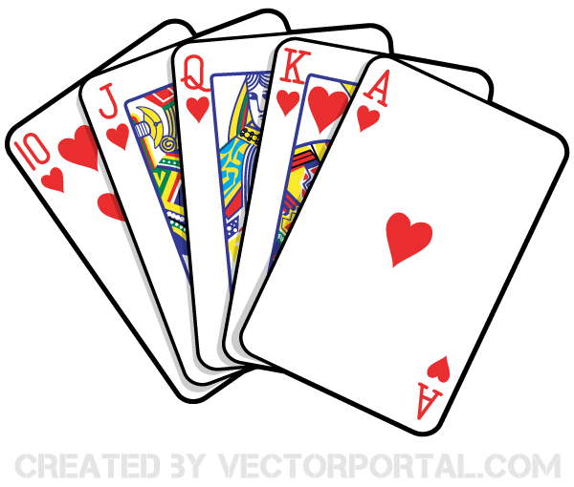  6:30 Power of Positive Speech (Synagogue) | 24  10:30 Chair Yoga (GB)  11:15 Relaxing Music  2:15 Bingo (WZ)  3:30 Montessori  6:30 Outdoor Time | 25 Erev Sukkot  10:30 Decorating the Sukkah (SVO Garden)  3:00 Preshabbat with Paula  3:15 Wine Time | 26 Sukkot 1  10:30 Walking Club  2:15 Coffee Cart
27 Sukkot 11
10:30 Chair Yoga (Goldbaltt)
2:15 Coffee Cart
Blessing of the Lulav and Etrog
28 Sukkot 111  10:30 Travel Talk Greenland  2:15 Hot Chocolate in the Sukkah  3:30 Hello Visits  6:30 Trivia Night (2nd floor)  Blessing of the Lulav and Etrog | 29  10:30 Stretch and Strengthen  11:15 Relaxing Music  2:30 Time in Sukkah  3:30 Hello Visits  6:30 Bowling (2nd floor)  Blessing of the Lulav and Etrog | 30 Orange Shirt Day  10:30 Residents Council (Theatre)  11:30 Food Committee 2:30 Truth and Reconciliation Program (Synagogue)  6:30 Power of Positive Speech (Synagogue)  Blessing of the Lulav and Etrog | 

