Legend:  SVO SV2  GD-Gould OK- Oak Knoll  GB-Goldblatt ES-Effort Square  ZK-Zucker  WZ-Weisz | 1  10:30 Obie Games (GD)  11:15 Relaxing Music  2:30 Spa Afternoon  3:15 Hello Visits  4 :15 Montessori  6:30 Men’s Club (Art Room) | 2  10:30 Hymn Sing (Theatre)  11:30 Hello Visits  2:30 Bocce Ball (SVO Garden)  3:00 Scrabble (GD)  4 :00 Montessori  6:30 Power of Positive Speech (Synagogue) | 3  10:30 Baskin Robbins Outing  11:15 Ask the Rabbi  2:15 Bingo (GB)  3:30 Montessori  6:30 Outdoor Time | 4  10:30 Chair Yoga (GB)  11:15 Relaxing Music  2:15 Bingo (GB)  3:15 Wine Time | 5  11:30 Coffee Cart  3:15 Hello Visits
6
10:30 Sing with Balabusta (Theatre)
2:15 Bingo (GB)
7 Labor Day  10:30 Snozelen  10:30 Walking Club  2:30 Cafe Time (Bubie’s)  4:15 Montessori  6:30 Bowling (2nd Floor Main Area) | 8  10:30 Tim Hortons Outing  2:30 Card Making for Rosh Hashanah (Art Room)  4 :15 Montessori  6:30 Men’s Club (Art Room) | 9  10:30 Breakfast Club (FDR)  2:30 Spa Afternoon  3:00 Scrabble (GD)  4:00 Montessori  6:30 Power of Positive Speech (Synagogue) | 10  10:30 Chair Yoga (GB)  11:15 Relaxing Music  11:15 Ask the Rabbi  2:15 Bingo (GB)  3:30 Montessori  6:30 Movie Evening | 11Erev Rosh Hashanah  10:30 Bingo (GB)  11:15 Relaxing Music  2:30 Decorating for Rosh Hashanah  5:00 Rosh Hashanah Dinner in Goldblatt  5:30 Rosh Hashanah Dinner in Gould | 12 Rosh Hashanah I  9:30 Ohev Zedek Service (Synagogue)  11;00 Coffee Cart  2:15 Hello Visits  3:15 Rosh Hashanah Service (Synagogue)
13 Rosh Hashanah II
9:30 Ohev Zedek Service (Synagogue)
11:30 Walking Club
2:00 Nondenominational Services (Goldie’s)
*Blowing of the Shofar*
14  10:30 Stretch & Strengthen (GB)  11:15 Relaxing Music  2:30 Concerts in Care (Synagogue)  4:15 Montessori  6:30 Movie Night (Theatre) | 15  10:30 Walking Club  11:15 Relaxing Music  2:30 Resident’s Council Celebration (Bubie’s)  4:15 Montessori  6:30 Bowling (2nd Floor Main Area) | 16 National Grandparents Day  10:30 National Grandparents Day (Theatre)  2:30 Sing with Judy (Bubie’s)  3:00 Scrabble (GD)  4:00 Montessori  6:30 Power of Positive Speech (Synagogue) | 17  10:30 Bible Study (Theatre)  11:15 Ask the Rabbi  11:15 Hello Visits  2:15 Bingo (GB)  3:30 Montessori  6:30 Outdoor Time | 18 Community Engagement Day  10:30 Fall Outing  1:00 Obie Games (OK)  1:30 Community Engagement Celebration Featuring Sam & Robin (SVO Garden)  3:15 1.1 Visits | 19  10:30 Coffee Cart  3:15 Hello Visits
20 Erev Yom Kippur
10:30 Kosher Cooking with the Balabusta (FDR)
2:15 Bingo (GB)
7:00 Ohev Zedek Kol Nidre Service (Synagogue)
21Yom Kippur  9:30 Ohev Zedek Service (Synagogue)  11:15 Walking Club  2:00 Hello Visits  3:45 Yom Kippur Service (Synagogue)  6:30 Hot Chocolate Cart | 22  10:30 Indigo Outing  12:30 Happy Birthday Dela (GD)  2:30 Wall Hanging for Sukkot (Art Room)  2:30 Oscar the Dog Visits  4:15 Montessori  5:30 Soup Program (Goldies) | 23  10:30 Stretch & Strengthen (GB)  11:30 Hello Visits  12:30 Happy Birthday Mrs. Kim (GD)  2:30 Sing with Cantor Paula (Bubie’s)  4:00 Montessori  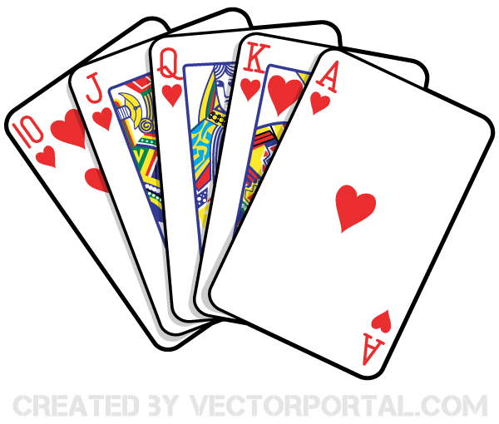  6:30 Power of Positive Speech (Synagogue) | 24  10:30 Chair Yoga (GB)  11:15 Relaxing Music  2:15 Bingo (GB)  3:30 Montessori  6:30 Movie Evening | 25 Erev Sukkot  10:30 Decorating the Sukkah (SVO Garden)  12:30 Happy Birthday GIgi (GD)  2:15 Hello Visits  3:00 Preshabbat with Cantor Paula (Synagogue) | 26 Sukkot I  10:30 Walking Club  3:15 Coffee Cart
27 Sukkot II
10:30 Chair Yoga (Goldblatt)
3:15 Hello Visits
Blessing of Lulav & Etrog
28 Sukkot III  10:30 Travel Talk: Greenland (Theatre)  2:30 Hot Chocolate in the Sukkah (SVO Garden)  3:30 Hello Visits  4:15 Montessori  6:30 Trivia (2nd Floor Main Area)  Blessing of Lulav & Etrog | 29 Sukkot IV  10:30 Stretch & Strengthen (GB)  11:15 Relaxing Music  2:30 Tea in the Sukkah (SVO Garden)  3:30 Hello Visits  4:00 Montessori  6:30 Bowling (2nd Floor Main Area)  Blessing of Lulav & Etrog | 30 Sukkot V  Orange Shirt Day  10:30 Resident’s Council (Theatre)  11:15 Food Committee (Theatre)  2:30 Truth and Reconciliation Program  (Synagogue)  4:00 Montessori  6:30 Power of Positive Speech (Synagogue)  Blessing of Lulav & Etrog | 

